Obesity Level Prediction Using Machine Learning and Lifestyle Factors

Caroline Iheanacho and Primrose Mncube

A Report Submitted in Partial Fulfilment
of the requirements for the
Degree of
BSc in Computing in IT (4th year)



May 2026

Supervisor:
Dr. Muhammad Iqbal

Abstract:
This research analyses the machine learning classification models used to predict obesity levels based on demographic, behavioural, and lifestyle factors. The study addresses the basic methodological issues in multiclass classification, feature selection, and model optimisation, as well as giving important insights into the factors that influence obesity classification.

The study uses the Obesity dataset and the CRISP-DM framework to guide the data analytics process, which includes data understanding, preparation, modelling, and evaluation. Three classification algorithms were used, decision tree, K-nearest neighbours (KNN), and Random Forest. These models were selected to represent different types of learning approaches, including tree-based, distance-based, and ensemble methods. To improve model performance, hyperparameter tuning was done using GridSearchCV, with weighted F1-score used as the key evaluation metric due to the problem's multiclass nature.

The research makes three main contributions. First, it evaluates the comparative performance of different classification algorithms in predicting obesity levels and identifies the most effective model for this task. Second, it examines the impact of hyperparameter tuning on model performance, demonstrating how optimisation improves classification accuracy and generalisation. Third, the study develops a prototype Obesity Risk Prediction Tool, illustrating how predictive models can be applied in a practical decision-support context for health awareness.

The findings give evidence for how suitable machine learning models for obesity classification, highlight the importance of model tuning, and highlight the potential of data-driven approaches in supporting the early detection of obesity risks. These findings help improve both academic understanding and practical applications in health-related predictive analytics.

Introduction
Obesity is a serious global public health concern, with growing rates in both developed and developing countries. It is associated with many different kinds of chronic health issues, including cardiovascular disease, diabetes, and reduced life expectancy. Obesity's complexity comes from the interaction of multiple factors, including demographic factors, eating habits, physical activity, and behavioural patterns. This complexity makes obesity an important area for data-driven analysis and predictive modelling.(World Health Organization, 2025)

Recent advances in data analytics and machine learning have enabled researchers to analyse large datasets and identify patterns that would have been difficult to identify using standard statistical methods. Decision Trees, K-Nearest Neighbours (KNN), and Random Forest are examples of machine learning classification algorithms that have been widely used in healthcare prediction applications due to the ability to handle non-linear relationships and complex feature interactions. These methods provide an opportunity to improve obesity classification and help in the early identification of those at risk. (Dritsas and Trigka, 2025)

The Obesity dataset used in this study contains demographic, behavioural, and lifestyle variables, allowing for a structured analysis of the factors that influence obesity levels. This research uses a machine learning approach to explore how these variables contribute to obesity classification and to analyse the effectiveness of different algorithms in predicting obesity categories. (archive.ics.uci.edu, 2019)

Problem statement

Despite the growing use of machine learning in healthcare analytics, there are still major challenges to using predictive models for obesity classification. Many current research studies are mainly concerned with model accuracy, without fully analysing the impact of model optimisation, feature selection, and algorithm comparison. Furthermore, there is often little discussion about how different classification models perform to one another when applied to the same dataset.

Another challenge is selecting appropriate evaluation metrics. In multiclass classification issues, such as obesity level prediction, focusing just on accuracy may not provide a complete picture of model performance. Precision, recall, and F1-score are more suitable metrics for assessing model performance across multiple classes. (Farhadpour et al. 2024)

In addition, much research lacks practical implementation. While predictive models are being developed, fewer research have shown how they might be turned into real-world applications that help decision-making and awareness. (“What Is Predictive Research and How Does It Work?”, 2026)
This research will address the gaps by comparing multiple classification models, by applying hyperparameter tuning to improve performance, and developing a prototype system to demonstrate practical applications. (Justus Akinlolu Ilemobayo et al. 2024)

The Aim and objectives
The main aim of this research is to develop and evaluate machine learning models for predicting obesity levels based on the demographic, behavioural and lifestyle factors.
To achieve this aims the research is guided by the following objective:
- To analyse and understand the obesity dataset using data analysis techniques.
- To prepare and process the data for machine learning models.
- To implement classification models such as Decision Tree, KNN, and Random Forest.
- To use hyperparameter tuning to improve model performance.
- To evaluate and compare models using appropriate metrics, such as accuracy, precision, recall, and F1 score.
- To create a prototype Obesity Risk Prediction Tool that shows the actual application of the models.

Research Questions

1. Which machine learning model provides the highest predictive performance for obesity classification?

2. How does hyperparameter tuning affect the performance of classification models?

3. Which lifestyle and behavioural factors are most important in predicting obesity levels?

4. How can predictive models be applied in a practical system for obesity risk awareness?

Methodology
Research Approach
This study adopts a quantitative data analytics approach using machine learning techniques to classify obesity levels. The research follows the CRISP-DM framework, which provides a structured methodology for data-driven projects. The framework consists of six phases: business understanding, data understanding, data preparation, modelling, evaluation, and deployment. (InstituteAdmin, 2025)
The use of CRISP-DM ensures a systematic approach to analysing the dataset, developing predictive models, and evaluating their performance.

Data Understanding

The dataset used in this project is the Obesity Dataset (ObesityDataSet_raw_and_data_sinthetic), which contains information related to individuals’ demographic characteristics, UCI (archive.ics.uci.edu, 2019).The dataset contains 2,111 rows and 17 columns, with each row representing an individual participant and each column representing a feature related to obesity, lifestyle habits, and demographic information.
The data understanding phase focuses on exploring and getting familiar with the dataset before building any machine learning models. At this stage, the goal is to understand what kind of data we are working with, identify patterns, and check for any issues that might affect the results later on.
The dataset used in this project contains information about individuals such as their age, gender, height, weight, eating habits, physical activity, and lifestyle choices.
From an initial inspection, it is clear that the dataset includes a mix of numerical values (such as age, height, and weight) and categorical variables (such as gender, smoking habits, and transportation type). The target variable, NObeyesdad, represents different obesity categories, which means this is a classification problem.
Understanding these variables is important because it helps identify which features may influence obesity levels and ensures the data is suitable for building predictive models.
Data Description
The dataset consists of several groups of variables:
- Demographic variables: Gender, Age
- Physical attributes: Height, Weight
- Eating habits:
  - FAVC (frequent consumption of high-calorie food)
  - FCVC (frequency of vegetable consumption)
  - NCP (number of main meals)
  - CAEC (consumption of food between meals)
  - CH2O (water consumption)
  - CALC (alcohol consumption)
- Lifestyle behaviours:
  - FAF (physical activity frequency)
  - TUE (technology usage time)
  - SMOKE (smoking habits)
  - SCC (calorie consumption monitoring)
- Family background:
  - family_history_with_overweight
- Transportation:
  - MTRANS
- Target variable:
  - NObeyesdad (obesity level category)

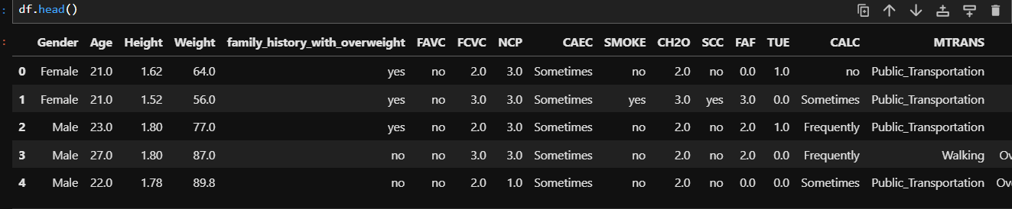Fig1: Preview of the Obesity Dataset Showing its features

Checking for missing Values
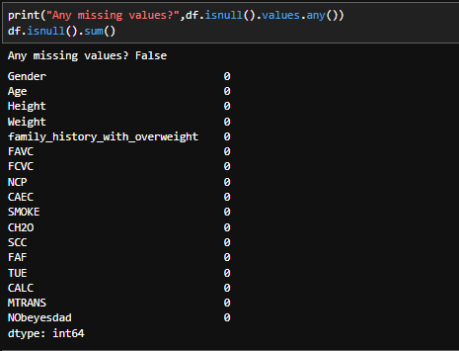
Fig : Missing Values Check
An important step in the data preparation stage of a machine learning project is looking for missing values. Because some algorithms are unable to properly interpret partial input, missing values can have a severe impact on the accuracy and performance of machine learning models.
The dataset's columns were examined using the `isnull()` function to find any missing values. The findings showed there were no missing values in any of the variables.
This indicates that no further data cleaning methods, like deleting rows or filling in missing information, were needed because the dataset is complete. It is advantageous to have a dataset free of missing values since it enhances data quality and guarantees that machine learning models may be trained more successfully and precisely.

Data Quality Assessment
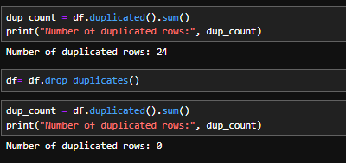
Fig: Checking for Duplicate Values
An essential step in the data preparation and cleaning process is looking for duplicate values. Because repeated data may introduce bias and lower the dependability of the results, duplicate rows can have a negative impact on machine learning models. Duplicate rows in the dataset were found using the `duplicated()` function. 24 duplicate records were discovered during the first check
The `drop_duplicates()` function was used to eliminate the duplicate rows in order to enhance the quality of the data. The dataset was examined once more after the duplicates were eliminated, and no duplicate rows were found. Eliminating duplicate values makes the dataset more precise, consistent, and appropriate for developing trustworthy machine learning models.

Exploratory Data Analysis

Target Variable Analysis
The target variable NObeyesdad represents different categories of obesity, making this a multi-class classification problem. We used a count plot to examine the different obesity categories
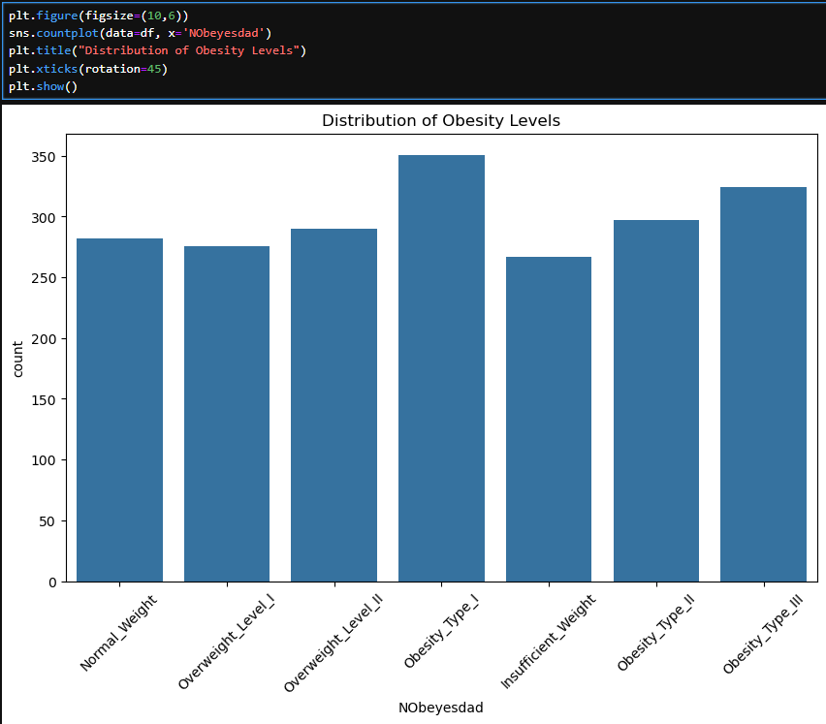
Fig 2: Distribution of obesity levels

Key Observation
This graph shows the distribution of obesity categories within the dataset.The dataset contains seven different obesity levels, including:Normal Weight, Overweight Level I, Overweight Level II, Obesity Type I, Insufficient Weight, Obesity Type II, Obesity Type III
The graph shows that the dataset is reasonably balanced because there are similar numbers of records in each category of obesity. Because balanced datasets lessen bias and enhance classification model performance, this is advantageous for machine learning.
Insufficient Weight has the fewest observations, while Type I Obesity has the most. All obesity levels are fairly covered in the sample, though, as the differences between categories are not very significant.The balanced distribution implies that the machine learning models will have sufficient data to identify patterns in each category of obesity, which can enhance model reliability and accuracy in prediction.

Age Distribution
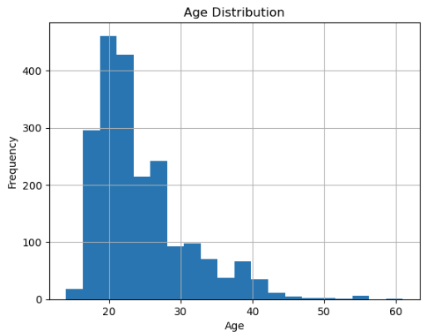
Fig: Age Distribution using Histogram
Observations
The majority of the dataset's participants are between the ages of 18 and 30, with the early 20s showing the largest density. This implies that young adults make up the majority of the dataset. There are fewer older people than younger people on the graph, which is positively skewed (right-skewed). The number of observations steadily declines after the age of thirty. Additionally, only a small percentage of individuals are older than 50, as evidenced by the few outliers.

Average Weight by Gender
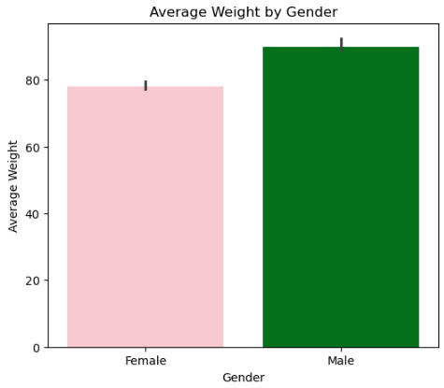
Fig: Weight by Gender using Barplot
Observations
This graph compares the average weight of males and females. The graph shows that males have a higher average weight compared to females.
The average weight for males is approximately 90kg, while the average weight for females is around 78kg. This suggests that male participants in the dataset generally weigh more than female participants.

Distribution of weight by gender
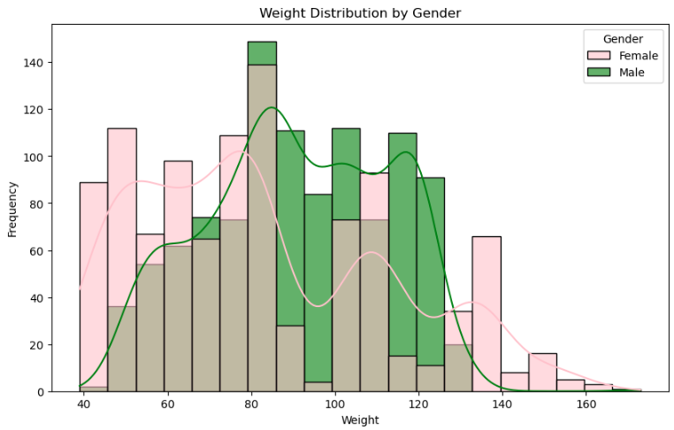
Fig: Distribution of weight by Gender
The weight distribution for men and women is displayed in this graph. Males are represented by the color green. The color pink is tied to women.
Males often have greater weight values, with the majority of males weighing between 85 and 120 kg, according to the graph. Compared to men, female weights are more dispersed, with some lower and higher weight values. Additionally, there is overlap between the two genders, particularly between 70 and 110 kg, indicating that many guys and girls have comparable weight ranges.

Height vs Weight by Obesity Level
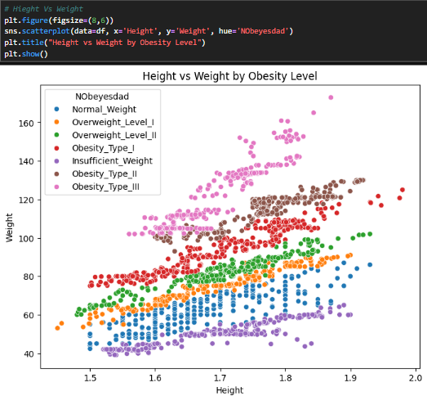
Fig 3:height vs weight scatterplot
Relationship between height and weight
We used a scatter plot to analyze the relationship between height and weight. From looking at the data is it evident that obesity categories are significantly more influenced by weight than by height. People are more likely to become obese as their weight increases, and this trend is rather constant across the dataset. In contrast, there is less variation in height between the various categories, therefore it is not as important for differentiating between them. Even though taller people tend to weigh more, the shift in the definition of obesity is actually driven by weight gain. Overall, data indicates that while height has a smaller and less obvious effect, weight is one of the most significant characteristics for predicting obesity levels.

High Calorie food consumption vs Obesity Level
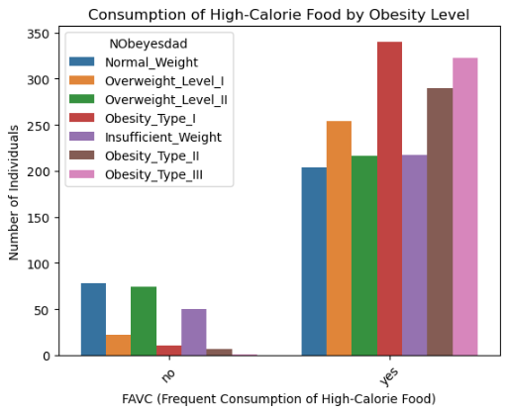
Fig 4: High calorie consumption vs obesity
The plot clearly demonstrates the connection between obesity levels and the use of high-calorie foods. People who regularly eat high-calorie foods (FAVC = yes) are significantly more likely to go into higher obesity categories than people who do not. On the other hand, people who don't often eat high-calorie foods are more likely to fall into the normal or lower weight groups. This implies that there is a strong correlation between growing obesity levels and frequent use of high-calorie foods.

Family History vs Obesity Level
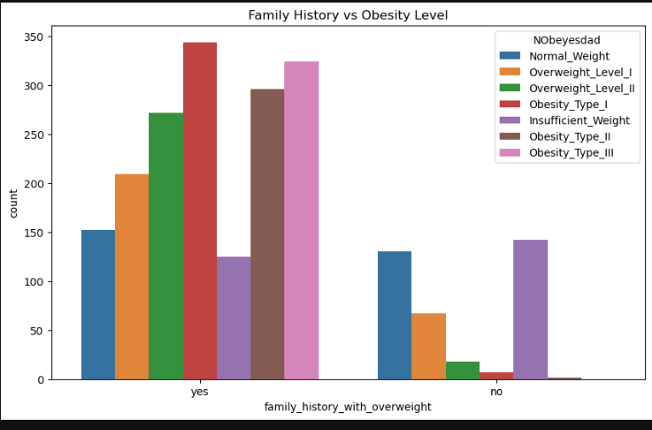Fig 5: Family History vs Obesity Level
This graph illustrates the connection between obesity levels and a family history of overweight.According to the graph, people who have a family history of being overweight ("yes") are more likely to fall into higher obesity classifications, including Type I, Type II, and Type III. On the other hand, people who do not have a family history of being overweight ("no") are more likely to fall into the Normal Weight and Insufficient Weight groups. Those without a family history of obesity have much lower counts in the obese categories. This implies that the risk of obesity may be significantly influenced by family history. The graph shows a strong connection between obesity levels and family history, suggesting that genetic or family-related factors may affect the dataset's obesity classification.

Average Physical Activity by Obesity level
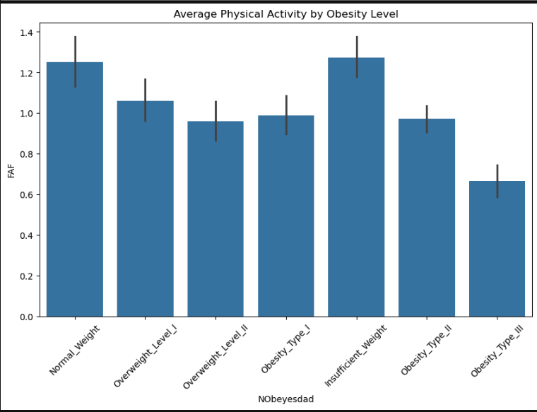
The average physical activity level (FAF) for each category of obesity is displayed in this bar graph. According to the graph, those with lower levels of obesity—such as Normal Weight and Insufficient Weight—generally engage in more physical activity on average.
The graph indicates that physical activity gradually declines as obesity levels rise, especially in the higher obesity groups. On the other hand, of all the groups, those who are categorized as Obesity Type III had the lowest average level of physical activity. Given that lower activity levels seem to be linked to greater obesity categories, these results imply that physical activity may be a significant factor in obesity levels.

Correlation Heatmap of Numeric Variables
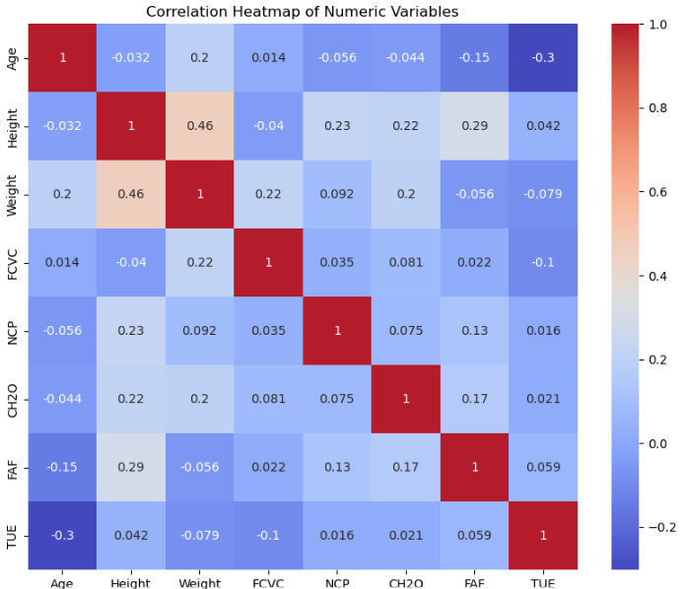
Fig : HeatMap of numeric Variables
The correlation between the dataset's numerical variables is displayed in this heatmap. The range of correlation values is -1 to 1.Taller people tend to weigh more, according to the dataset's greatest positive association between height and weight (0.46)
The somewhat negative connection between age and TUE (-0.30) suggests that technology usage time may gradually decline with age. There is a tiny positive correlation (0.29) between height and FAF (physical activity), indicating that taller people may engage in somewhat more physical exercise. The majority of other factors exhibit modest correlations, indicating that their individual effects are not very substantial.
All things considered, the heatmap aids in determining correlations between variables and offers helpful information about which characteristics can be crucial for machine learning analysis and obesity prediction. Most other variables show weak correlations, meaning they do not strongly influence one another individually. Overall, the heatmap helps identify relationships between variables and provides useful insight into which features may be important for obesity prediction and machine learning analysis.
Summary of data understanding
Important insights into the dataset's structure and features were discovered throughout the data understanding phase. The dataset was found to include a range of physical, behavioral, and demographic factors, all of which are important for predicting obesity levels.Weight was found to be the most significant factor among these variables, demonstrating a distinct difference across various obesity classifications. This suggests that weight is crucial for class differentiation and will probably be a major predictor throughout the modeling stage.
Obesity levels were found to be significantly impacted by lifestyle factors, including food preferences and physical activity, in addition to physical characteristics. These variables showed substantial trends, indicating that behavioral factors have a major role in the classification of obesity.
However the analysis also brought to light a few issues with the dataset. All of the obese groups showed some degree of class imbalance, and there was some overlap between adjacent classes. These elements have to be taken into account during the modeling and evaluation stages since they may have an impact on model performance.
Data Preparation
This step is related to the CRISP-DM framework's Data Preparation phase, during which the dataset is processed, cleaned, and ready for modeling.(InstituteAdmin, 2025)
The raw dataset must be converted into a format that machine learning models can use during the data preparation stage. This step is crucial since the models' dependability and performance are directly impacted by the quality of the input data. Managing data quality concerns, encoding categorical variables, choosing pertinent features, and dividing the dataset for testing and training were all part of the preparation process.

Modelling
This stage of the CRISP-DM framework focuses on developing machine learning models capable of classifying obesity levels based on demographic, behavioural, and lifestyle variables. Multiple classification algorithms were implemented and compared to identify the most effective predictive approach for the obesity dataset. The modelling process included data splitting, model training, hyperparameter tuning, and evaluation using multiclass classification metrics such as accuracy, precision, recall, F1-score, and confusion matrices.(“CRISP-DM Explained: A Proven Data Mining Methodology | Udacity”2025)
For this research, three machine learning algorithms were chosen: Decision Tree, Random Forest, K-Nearest Neighbors (KNN). These models were selected because they work well on structured datasets with both numerical and categorical characteristics and are frequently used for classification tasks.
The Decision Tree model was selected because it is simple, transparent, and easy to interpret. It clearly demonstrates how decisions are made based on feature values, making it suitable for structured data such as tables and spreadsheets. Decision Trees are also effective for small to medium-sized datasets and can produce quick results while remaining easy to understand and visualise.(Srikanth R, 2025)
Random Forest is its ability to identify feature importance, helping determine which variables have the greatest influence on obesity prediction. The algorithm is also robust and can handle complex datasets effectively after preprocessing. Due to its strong predictive performance and versatility, Random Forest is widely used in many real-world machine learning applications.(Samy Baladram, 2024)
The obesity dataset contains structured numerical and categorical data with patterns that can be found based on similarity between observations, which is why K-Nearest Neighbors (KNN) was chosen for this research. (GeeksforGeeks, 2017) KNN can compare people and categorize obesity levels based on the closest data points in the dataset using features like age, height, weight, physical activity, and eating habits. KNN is especially appropriate for this project because obesity categories frequently have similar traits. People that share similar weight, lifestyle choices, and levels of physical activity, for instance, are likely to fall into similar obesity categories. The method assigns the most prevalent obesity category among the closest neighbors by calculating the distance between data points.
To improve model performance, hyperparameter tuning was performed using GridSearchCV to identify the best parameter combinations for each algorithm. The models were then evaluated and compared to determine which algorithm achieved the best overall performance for obesity prediction.

Model selection
Decision Tree

References
- archive.ics.uci.edu. (2019). UCI Machine Learning Repository. [online] Available at: https://archive.ics.uci.edu/dataset/544/estimation+of+obesity+levels+based+on+eating+habits+and+physical+condition.
- InstituteAdmin (2025). Understanding the CRISP-DM Methodology for Data Science Projects. [online] Business Analytics Institute. Available at: https://businessanalyticsinstitute.com/understanding-the-crisp-dm-methodology-for-data-science-projects/.[Accessed
- Srikanth R (2025). Introduction: Why Choosing the Right Model Matters In machine learning, choosing the right algorithm is just as important as collecting the right data. Two of the most commonly used models—Decision Trees and Neural Networks—approach problem-solving in very different ways. [online] Linkedin.com. Available at: https://www.linkedin.com/pulse/understanding-decision-trees-neural-networks-strengths-srikanth-r-kqj8c/.
- ‌Samy Baladram (2024). Random Forest, Explained: A Visual Guide with Code Examples | Towards Data Science. [online] Towards Data Science. Available at: https://towardsdatascience.com/random-forest-explained-a-visual-guide-with-code-examples-9f736a6e1b3c/.
- ‌GeeksforGeeks (2017). KNearest Neighbor(KNN) Algorithm. [online] GeeksforGeeks. Available at: https://www.geeksforgeeks.org/machine-learning/k-nearest-neighbours/.
- ‌

‌

‌

